**Autonomous Robotic System for Playing a Static Turn-Taking Chess Game with a Human Partner**

Mohammed Omair Siddiqui

M00841284

**Abstract**

In this application, we designed autonomous robotic system for playing a static turn taking chess game with a human partner. There are total 4 steps used to design complete application. First part includes design of robot model using sensors and actuators. Second part consists of computer vision algorithm which analyse chess board as image and identify specific color for placing next move. Third algorithm is an integration of computer vision algorithm with robot model. Forth step has an algorithm which identifies next move depending on instruction sequence. We used programming language Python to connect actuators and sensors with camera. Python is more efficient and adaptive language.

**Keywords:** Autonomous robot, computer vision, controller, motor, sensors, actuators, instruction sequence.

**I.** **Introduction**

In this application we designed a model which can play chess game with human and interaction is more efficient than state of art works. There will many questions while designing such application like, how next move can be predicted? how robot can move in 3 coordinates?

How motor voltage and movement can be controlled?

**CHESS GAME BASICS**

This is one of most popular and oldest game which uses board. Black and white colours are commonly used for chess game. Capturing the opponent’s king is the main objective this game.

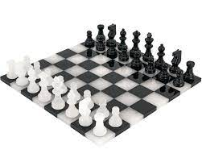

**Fig.1 commonly used chess board**

Chess game shows 2 kingdom war played by 2 players. It’s not a luck-based game as hidden steps or turns can be played between players. Many rules and pieces with complex game strategies. [1]

For playing timed game there is need of timer and to maintain record score card is required. Based on colours chess has two players which contains total 32 pieces, 16 each colour. 16 pieces of 1 army contains a king, a queen, two rooks, two bishops, two knights and eight pawns. Movement of every piece from chess is distinct. Player needs to save his king from attackers’ range. If he is unable to save then king is in ‘checkmate’ state and game terminates. There are even some special rules are available in chess as En Passant capture, pawn promotion and castling. [2]

In existing different models of robot which are used for playing chess games with manipulators such as mobile one which is costlier and movements are not proper. Hall sensors and reed switches are used for position tracking, if there is any jerk on robot then tracking may get disturbed causing inaccurate outcomes.

Stockfish is available which is open source that is used for finding closest next moves. Camera is used at top and magnetic head is used at the bottom of chess which helps in piece movement. XY direction-based slider is used which is controlled by CNC for moving pieces around the chess board. CNC slider is used for movement of Stockfish based board is one of the best configurations used in existing techniques.

Chess pieces of cylindric size are used with wooden are used for best experience [3]. DFW-VL500 Sony camera used for better vision which even removes artifacts.

Robot used in such applications is Robix RC6, this robot model can be used for even education and entertainment purpose. Grippers are used for smooth handling of picking and placing scenario. Grippers are long size to avoid collision between cylindrical pieces used and to get higher accuracy. There are three layers used for chess solving robot as chessboard model layer, board position layer and classification of pixel layer.

3 DOF (Degree of Freedom) model is used for designing a chess playing robot in real time with opponent. In this, there is need to set ROI (Region of interest) to find intersection points and corners from given chess board. Chess move occupancy can be set based on vision algorithm [4]. CAD software is used for Modeling in this which determines force and stress

.

**II.** **Challenges faced in design**

1.Board positioning and brightness are varying which can cause varying results

2. Trade-off between time complexity and accuracy must be achieved for real time interaction with human partner.

3. Limited accuracy of sensor as well as actuators.

4. Thick robot pliers can cover limited distance

**III.** **Proposed Design**

There are total 4 parts in this application as mentioned below,

1. Overall Design of a Robot Model

2. Design of Computer Vision Algorithm

3. Preparation of Chess Game using Robot Model and Computer Vision Algorithm

4. Instruction Sequence for next moves

Below there is explanation of all four steps in detail,

**3.1** **Overall Design of Robot Model**

Robot must have 4 degrees of movement using bearings; one is for horizontal movement and another 3-degree movement for x, y and z co-ordinates.

**Actuator:** Total 5 motors are used in this model in which 4 motors are used for 4-degree movement and fifth is used for pliers.

**Sensors:** These motors use DC current as well as voltage of -5 to +15 volts. Voltage values can be obtained from angular movement of potentiometers. Potentiometers are more accurate with better precision.

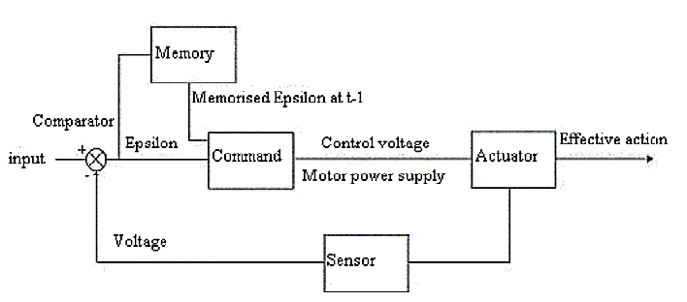

**Fig.2 sensors and actuators used for robot control**

First, we need to select proper co-ordinates for movement. Motion planning can be done using digital to analog converter. High level programming language such as Python is used for communicating between sensors and actuators. A controller such as Arduino is used for controlling actuators.

Multiple Sensors are used in this application which includes basic three types as,

1. **Touch Sensors**
2. **Vision Sensors**

And for response to sensors is given by actuators. Below there is complete information about all sensors and actuators. Internal components and environment information can be obtained from robot. For certain environment or condition sensors should act accordingly. Real time safety and measurements are very important for given robot. Depending on any malfunction we must get alarm or warning for robot so that particular action can be taken.

**Tactile sensors:**

Existing research on generated hand as well as prosthetic hand gives less accuracy of sensation. To overcome these drawbacks in this application there is use of tactile sensors which provides touch similar to human fingertips and mechanical properties are used similar or mimic to human hand structure. Rigid layer is surrounded to tactile sensor-based hand which has skin like elastomeric. In such sensors, impedance properties are used for producing grip to pick up the target object.

**Vision Sensors**

Here real times video scenario is going on in which we capture video which means sequence of frames are collected from given scene. Less delay between sequences of frames generates the video again. Solid state physics concepts are used to design sensors for computer vision applications. IR light sensors and visible light sensors are detecting electromagnetic radiations generated. Like human eye it should detect objects and track the current move on chess.

Many intelligent cameras can be used for producing robot eye similar to human eye which senses many things from environment. Machine and deep learning techniques which are trending in robotics are used for generating more perfect vision. Intelligent cameras are available in market which helps for robotic vision.

There are some other sensors that can be used but in these applications, we did not use sensors such as Sonar, Radar and Lidar which can be used for target detection. Vision sensors should identify the pattern of chess.

**Sensors and specifications**

**1.** Environment Detector Sensors:

IR sensor: 10 to 80 cm/ 1mm

Mini -camera: 120*120 pixel

2. Gripping force sensor

Flexi force sensors: 1-110N/0.1N

3. Proximity Sensor

PSD-Laser Sensor: 0-3 cm /1 mm

Environment detector sensors are used to understand overall scenario of surroundings in chess environment. IR sensor and mini camera are used for environment sensor.

**IR sensor Module**

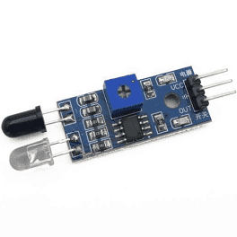

**Fig.3 IR sensor Module**

IR sensor module detects if there is any obstacle in front of the robot and then obstacle avoidance program can be written in programming language as mentioned and the instruction is given to actuators to avoid obstacle.

**Mini -camera module**

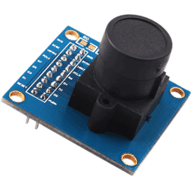

**Fig.4 Mini Camera Module: OV7670**

Mini camera module gives 120*120-pixel pixels as input. Camera can be used for vision purpose and many algorithms can be used for identifying pattern and type of piece and next move.

**Gripping force sensor:**

This is addition of all forces including grippers force. All dynamic and static pressure from objects is calculated.

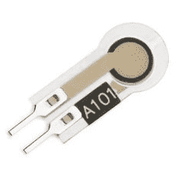

**Fig.5 Flexi-Force Calculation Sensor**

We used Flexi force sensors with specification 1-110N/0.1N.

**Proximity Sensor**

It has ability to find objects in given environment without real touch. So this sensor is much useful as it avoid damage of chess pieces and make pieces safe.

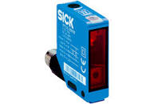

**Fig.6 Proximity Sensor: PSD-Laser Sensor**

PSD-Laser Sensor is used with specification 0-3 cm /1 mm.

**Actuators**

For movement of chess robot purpose, we are using actuators. Robot joint and wheels movement can be controlled by using actuators [2]. There are basically two types of electric actuators as AC actuators and DC actuators. In these applications we used DC actuators with electric specification. For actuators mostly the input is in the form of voltage or current or signal impedance which can be generated using sensors and then this sensors information can be converted to motion which can be controlled by control motion.

Actually, robot function and power required says that which actuators are better for chess game through automatic way. Pneumatic actuators are best among rest actuators. Pneumatic actuators and hydraulic actuators are costlier. Electric actuators are the best choice with high initial cost and even renewable energy sources can be used with them for clean nature.

Linear actuators will get linear movement of push rod from rotational movement. It can be automatic control or remote controlled. [3]

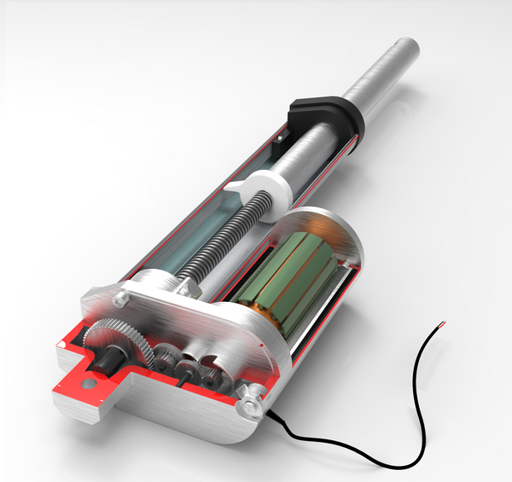

**Fig.7 12 V DC actuator selected for this proposed design**

Specifications of actuator selected

* Voltage: 12V , 24 V DC
* Load Capacity: 100N-20000N
* Stroke: 50 mm, 100 mm

Many components are inside this actuator are as micro-control switch , spring , push rod , nut , screw, reduction gear and drive motor ,etc.

1. **Design of Computer Vision Algorithm**

In this, there is use of computer vision based algorithms such as image acquisition, image filtering, image segmentation and template matching. In this first we will capture the image using camera from which is called as image acquisition, acquired image is then passed through image filtering to remove noise and image enhancement is used for making image clearer. Image segmentation is used for detecting only chess board points and getting chess moves. Template matching or any recent machine learning algorithm can be used for detecting type of move need to take.

**2.** **Preparation of Chess Game using integration of Robot Model and Computer Vision Algorithm**

For avoiding movement of chess engine twice, transposition table is used. Most effective next moves can be decided based on path searching algorithms such as breadth-first-search. For more possibility check there is need of database which consists of multiple chess images.

Multiple rules can be created and evolved using chess engine designed in this application based on position evolved. There are basic three levels in this, first stage is opening stage, second stage is middle game stage and final stage is ending stage. The robot model and computer vision algorithms work differently at all these three stages and their behaviour can be decided by users.

**3.** **Instruction Sequence for next moves**

There are basically some instructions such as play move, move piece, lift piece, take away piece and put down piece are used for providing next move instructions to the chess engine.

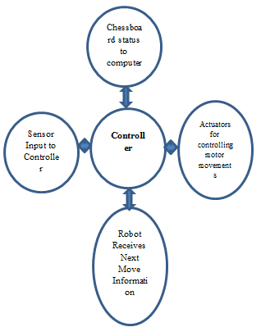

**Fig.8 Controlling Next Moves for Autonomous Robot**

As shown in above figure, there are 4 ways information transfer will take place.

1. Providing sensor information to controllers
2. Checking chess status from computer using computer vision
3. Use of actuators for providing motor movement control
4. Providing next move information to autonomous robot

**Physical Design of Autonomous Robot**

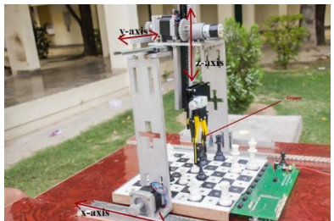

**Fig.9 Physical design of chess solving autonomous robot**

Robot structure should perform three tasks such as,

1. Information perception
2. Processing on information
3. Actions by actuators

Information perception can provide the detailed behaviour requirement in particular situations. Processing on information will give sensory information from sensors to actuator. According to the information received actuators move in given direction

**Conclusion**

Complete study of design and analysis of robot model for chess playing is studied in this paper. The important four steps need to consider while designing autonomous chess playing robot. Python programming language used for sending instruction to controllers according to sensor information.

As there is use of three steps as selection of data from image sensors, operating on obtained data and sending instruction to player for next move.

**Future Scope**

**A)** LED Visualization

More efficient way of understanding the working of proposed application is using LED visualization. 9 LEDs on row side and 9 LEDs on column side are used in matrix format so total 81 LEDs can be used for this application. For generating LED visualization, simple LED with soldering can be mounted on PCB. Anode connection can be given with red wires and cathode connections can be given with grey wires. Eagle software can be used for programming the PCB used for mounting LEDs.

**B)** Modified structure Pieces

Modified piece structure can be used to get better grip and avoid obstacles easily. To do so we need to modify the structure of pieces used for chess.

**C)** Very High-Resolution Cameras

In this application we used mini camera but even high-resolution cameras may help us to get perfect grip and capture, so that pick and place is easy for next move.

**Appendix A**

**Programming Language: Python**

Python is very powerful programming language for designing robotic and computer vision applications. As chess game need both computer vision and robotic model support packages, python provides support packages freely with advanced and upgraded packages. Python and C++ are combinly used for real and simulated robot which makes interface easy to use.

Machine learning tools / packages are widely used for designing ROS (Robot Operating System). There is need of python libraries for designing these applications such as NumPy, Pandas, Sci-kit, and Matplotlib.

Python is a key language used for robotics application design. Robotics researchers and many tech developers are using python integrated with embedded system. In this application both python and C++ are used for designing ROS (Robot Operating System). Python provides easiness for design while C++ has better performance over other programming languages.

C++ has better performance over many languages so its commonly used high level technical computing language.

# References

|  |  |
| --- | --- |
| [1] | "Robotics," Wikipedia, [Online]. Available: https://en.wikipedia.org/wiki/Robotics#Sensing. |
| [2] | Chess.com, "Chess Terms," Chess.com, [Online]. Available: https://www.chess.com/terms/chess#what-is-chess. |
| [3] | D. U. a. Y. Berbers, "Marine Blue: A Low-cost Chess Robot," in *Conference: IASTED International Conference Robotics and Applications*, Salzburg, Austria, June 25-27, 2003. |
| [4] | N. Banerjee, "A Simple Autonomous Chess Playing Robot for playing Chess against any opponent in Real Time," in *International Conference on Computational Vision and Robotics*, Bhubaneswar, India, August 2012. |
| [5] | U. o. Reading, "Sensors and Actuators," Future Learn, [Online]. Available: https://www.futurelearn.com/info/courses/begin-robotics/0/steps/2860#:~:text=An%20actuator%20is%2. |
| [6] | ATO, "Linear Actuators," ATO, [Online]. Available: https://www.ato.com/linear-actuators. |